**Step 1;** Look out for Email from **Helios Voting Bot** [no-reply@mail.heliosvoting.org](mailto:no-reply@mail.heliosvoting.org)

**3; Click Start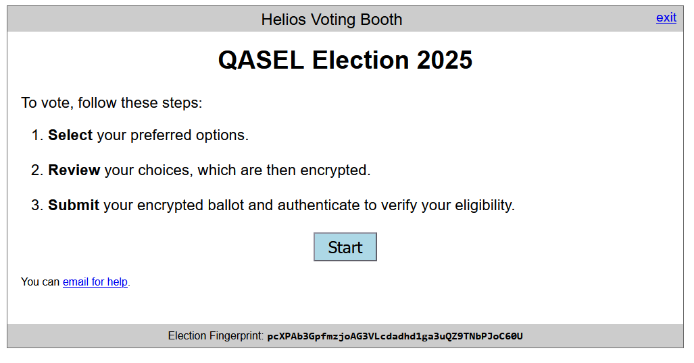  
**4;** Select exactly 2 nominees and click proceed – See <https://www.qasel.org.au/elections> for nomination statements

**  
**6;** Login using voter id and password from **Step 2.** Click Authenticate & Cast ballot.